Title | VT5 Front End and Communication Board Communication Protocol
Distribution | Software Archive
Author | Merrick. Huang | Date | 2013-05-20
Review | Spring Zhou  Zuochen Wang | Date | 2013-05-23
Approved |  | Date
Remarks

Contents

1 Introduction 3
2 Communication Protocol 3
2.1 Communication architecture 3
2.2 Communication protocol 3
2.2.1 Data Link layer – OSI 2 4
2.2.2 Application layer – OSI 7 7
2.2.3 Error event handling 17
3 Design decisions 17
4 Performance Analyze 20
5 Safety Design Analyze 20
Reference 23
Revision History 23
Review 24

List of Figures
Figure 1. Communication between Master and Slave 3
Figure 2. Message type / status byte 6
Figure 3 Connection between front end board and communication board 18
Figure 4 Communiocation board work flow chart. 19
Figure 5 Front end board work flow chart 20

List of Tables
Table 1. UART OSI layers 3
Table 2. Message structure 6
Table 3. Message type / status field description 6
Table 4. Message structure of master read request 7
Table 5. Message structure of slave reply – with valid data 7
Table 6. Message structure of slave reply – No data 8
Table 7. Read frame description 8
Table 8. Diagnosis information (Data 12) field description 12
Table 9. Diagnosis information (Data 13) field description 12
Table 10. Message structure of master write request 13
Table 11. Message structure of slave reply for master write request 13
Table 12. Write frame description 13
Table 13 UART Signal Descriptions 18

Appendix A Meter code

Introduction
The document specifies the communication interface between the communication board and the front end board in VT5 Vortex/Swril Flow meter.

Communication Protocol

Communication architecture
The communication protocol between Front-end and communication board is based on
- UART physical layer, including OSI layer 2 and layer 7
  - Layer2 - Data link layer will re-use Modbus frame strategy( T35 is used to judge one entire frame)
  - Layer7 – VT5 specific command
- Master-Slave architecture.
  - Half - duplex

Table 1. UART OSI layers
OSI Layer | Remark
Layer 7 | Application layer
Layer 2 | Data linker layer
Layer 1 | UART physical layer

Communication board acts as the master and Front-end is the slave.
Communication Board (Master)
Front-end (Slave)
Request
Acknowledge
Figure 1. Communication between Master and Slave

As remote communication (30m) needs supporting between communication board and front end board, baud rate is limited to 19200bps.

The UART accepts or sends data complying with the following configuration:
• 1 START bit.
• 8 data bits.
• 1 PARITY bit (Odd parity selected).
• 2 STOP bits.

T35 is about 2.1ms when baud rate is 19200bps.

Communication protocol

Data Link layer – OSI 2

Master state machine
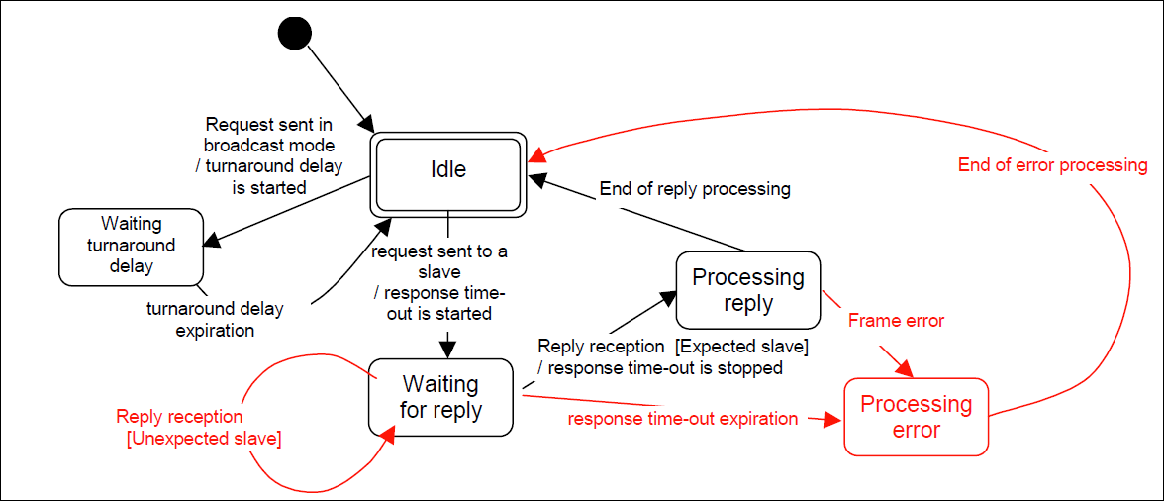

Slave state machine
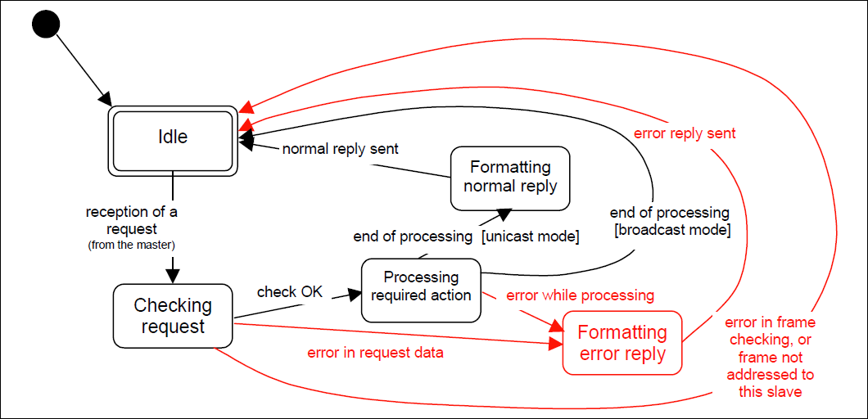

Master and Slave Transmission
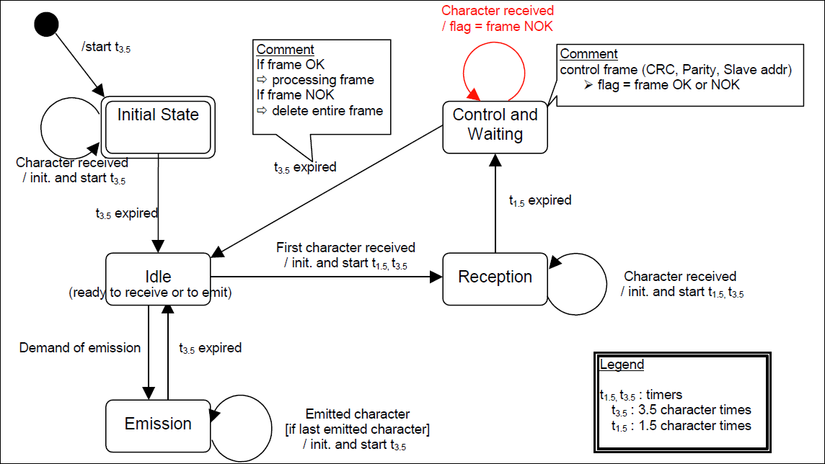

Transition from "Initial State" to "Idle" state needs t3.5 time-out expiration: that insures inter-frame delay
  - "Idle" state is the normal state when neither emission nor reception is active.
  - In RTU mode, the communication link is declared in "idle" state when there is no transmission activity after a time interval equal to at least 3.5 characters.
  - When the link is in idle state, each transmitted character detected on the link is identified as the start of a frame. The link goes to the "active" state. Then, the end of frame is identified when no more character is transmitted on the link after the time interval t3.5.
  - After detection of the end of frame, the CRC calculation and checking is completed. Afterwards the address field is analyzed to determine if the frame is for the device. If not the frame is discarded. In order to reduce the reception processing time the address field can be analyzed as soon as it is received without waiting the end of frame. In this case the CRC will be calculated and checked only if the frame is addressed to the slave (broadcast frame included).

Frame
Messages between master and slave are aimed at length variable frames [1]. A message, either from the master or from the slave, is composed of (n+7) 8-bits bytes (where n is data number in frame), as depicted in Table 4.

Table 2. Message structure
Message type/Status
Frame number
Command code
Subcommand code
Data length
Data 0
Data 1
...
Data n-2
Data n-1
CRC0
CRC1
- Message type / Status (1 Byte)

7 | 6 | 5 | 4 | 3 | 2 | 1 | 0
Reserved | Reserved | Reserved | Frontend  Busy | Reserved | CRC error | Serial Data Ok | Read/Write  CMD
Figure 2. Message type / status byte

Every error or condition has one corresponding bit in the header. This is the reason, why more than one error can be reported at once. The fields implemented yet, have the following meanings:

Table 3. Message type / status field description
Bit | Field | Value | Description
0 | Read/Write  CMD | 0  1 | Read or write message command.  Read data.  Write data.
1 | Serial Data Ok | 0  1 | There was no error. Also used as void word for synchronous communication.  Normally the complete header is never zero. If it is, there is a shortcut at the serial line. If this bit is zero, an error occurred and the error bits must be interpreted to handle it.  Serial data error.  Serial data OK.
2 | CRC error | 0  1 | CRC error for the frame. This bit is only in slave’s frame. Master always clears this bit.  No CRC error.  CRC error.  When CRC error has been detected (CRC error = 1), the Serial Data OK bit is cleared.
3 | Reserved | 0 | Reserve for other packet error
4 | Frontend  busy | 0  1 | Front end busy state bit.  Front end is idle  Front end is busy  If Front end is in busy state, commands received from communication board is invalid.
5 | Frontend data access error | 0  1 | Front end data access state bit.  Front end data read/write OK  Front end data read/write error.
7-6 | Reserved | 0 | The other 3 bits are left for future use.

- Frame number(1 Byte)
Master is responsible for setting frame number. Frame number ranges from 0 to 255. Slave sends package to master with the same frame number it received.

- Command Code(1 Byte)
This byte indicates which type of data is to be read or written. Details are described in Table 7 and Table 12.

- Subcommand Code (1 Byte)
It shows command information combining with command code. Only command 128 uses subcommand code.

- Data Length (1 Byte)
Data length shows the number of message data 0 – n-1.

- Data (n Bytes)
Data bytes.

- CRC (2 Bytes)
CRC16 CCITT standard.
CRC0 – Low 8 bits
CRC1 – High 8 bits.

Application layer – OSI 7
There are read and write messages / Requests.
- Read messages - The master (CB) reads at most xx data bytes from the slave (FE)
-  Write messages - The master (CB) writes at most xx data bytes to the slave (FE)

Read frame
Master reads data from slave. The typical example is the periodical reading of the computations done in every algorithm cycle [1].
All data are aligned in little endian mode.

Master Request

Table 4. Message structure of master read request

Message type/Status
Frame number
Command code
Subcommand code⁽¹⁾
Data length
CRC0
CRC1

Slave Reply
Table 5. Message structure of slave reply – with valid data

Message type/Status
Frame number
Command code
Subcommand code⁽¹⁾
Data length
Data 0
Data 1
...
Data n-2
Data n-1
CRC0
CRC1

Table 6. Message structure of slave reply – No data

Message type/Status
Frame number
Command code
Subcommand code⁽¹⁾
Data length
CRC0
CRC1
Notes:
- Only command 128 uses subcommand code.

In normal communication state, slave replies master using message type in Table 5. Once slave detects CRC error in master’s read frame or slave data access error, slave will use message type in Table 6 to reply master.

Table 7. Read frame description
Command code | Subcommand code | Command Name | Data index Description / Byte
0 |  | Read Meter Configuration | - 0: Meter Code. Described in Appendix A.  - 1：Temperature sensor code.  0--PT100, 1--PT1000, 2--None
1 |  | Read Calculation data | - 0,1,2,3: Frequency(Little endian)  - 4,5,6,7: Temperature  - 8,9,10,11: SNR  - 12,13: diagnosis info –(Described in Table 8 and 9)  Frequency – 32bits float, Hz  Temperature - 32bits float, Degree Celsius  SNR - 32bits float, dB
2 |  | Read Signal amplitude | - 0 : Year of amplitude 0  - 1: Month of amplitude 0  - 2, 3, 4, 5: Value of amplitude 0 in time domain.  - 6, 7: Value of amplitude 0 in freq domain  - ... …  - 88 : Year of amplitude 11  - 89: Month of amplitude 11  - 90, 91, 92, 93: Value of amplitude 11 in time domain  - 94, 95: Value of amplitude 11 in freq domain.  Year – 8bits unsigned int  Month – 8bits unsigned int  Amplitude in time domain–32bits float, Volt  Amplitude in freq domain – 16bits unsigned int, less than 32767.
3 |  | Read Vibration amplitude | - 0 : Year of amplitude 0  - 1: Month of amplitude 0  - 2, 3, 4, 5: Value of amplitude 0 in time domain.  - 6, 7: Value of amplitude 0 in freq domain  - ... …  - 88 : Year of amplitude 11  - 89: Month of amplitude 11  - 90, 91, 92, 93: Value of amplitude 11 in time domain  - 94, 95: Value of amplitude 11 in freq domain.  Year – 8bits unsigned int  Month – 8bits unsigned int  Amplitude in time domain–32bits float, Volt  Amplitude in freq domain – 16bits unsigned int, less than 32767.
4 |  | Read Operation Hours | - 0, 1, 2, 3: Front end operational hours  Operation hour – 32bits unsigned int
5 |  | Read Front end RTC | - 0: Year  - 1: Month  - 2: Date  - 3: Hour  - 4: Minute  Year – 8bits unsigned int  Month – 8bits unsigned int  Date – 8bits unsigned int  Hour – 8bits unsigned int  Minute – 8bits unsigned int
6 |  | Read Front end Maintenance cycle | - 0, 1, 2, 3: Front end maintenance cycle  Maintenance cycle – 32bits unsigned int
7 |  | Read DSP Params | - 0: Vbr correction on  - 1-2: Vbr filter step  - 3: Vbr filter num of coefs  - 4: FCD on  - 5: FCD shift bit  - 6: FCD delay value  - 7: FCD num of coefs  - 8: Lock in min integration period  - 9: Lock in max integration period  - 10: Lock in estimation error margin in percentage  - 11: Accuracy in high sampling buffer  - 12: Accuracy in middle sampling buffer  - 13: Accuracy in low sampling buffer  - 14: Analogue gain  - 15: Gain control on  - 16-17: Gain control low threshold  - 18-19: Gain control high threshold  - 20-21:Gain control margin in freq domain  - 22: Gain control max shift bits  - 23: Low flow threshold on  - 24-25: Low flow threshold  - 26-27: Low flow threshold coefficients  - 28: Noise sampling size bits  - 29: Static decimation bits  - 30: Middle buffer decimation bits  - 31-34: Max flow freq  - 35-38: Min flow freq  - 39: Freq min margin in percentage  - 40: Freq max margin in percentage  Vbr correction on - Bool  Vbr filter step - 16bits unsigned int  Vbr filter num of coefs - 8bits unsigned int  FCD on - Bool  FCD shift bit - 8bits unsigned int  FCD delay value - 8bits unsigned int  FCD num of coefs -8bits unsigned int  Lock in min integration period - 8bits unsigned int  Lock in max integration period - 8bits unsigned int  Lock in estimation error margin in percentage - 8bits unsigned int  Accuracy in high sampling buffer - 8bits unsigned int  Accuracy in middle sampling buffer - 8bits unsigned int  Accuracy in low sampling buffer - 8bits unsigned int  Analogue gain - 8bits unsigned int  Gain control on - Bool  Gain control low threshold - 16bits unsigned int  Gain control high threshold -16bits unsigned int  Gain control margin in freq domain - 16bits unsigned int  Gain control max shift bits - 8bits unsigned int  Low flow threshold on -Bool  Low flow threshold - 16bits unsigned int  Low flow threshold coefficients -16bits signed int  Noise sampling size bits - 8bits unsigned int  Static decimation bits - 8bits unsigned int  Middle buffer decimation bits - 8bits unsigned int  Max flow freq -32bits float  Min flow freq - 32bits float  Freq min margin in percentage - 8bits unsigned int  Freq max margin in percentage - 8bits unsigned int
8 |  | Read FE SW/HW revision | - 0 -2: Hardware revision.  - 3 -5: Software revision.  Hardware revision – Three 8bits unsigned int (last byte is highest revision number.)  Software revision – Three 8bits unsigned int (last byte is highest revision number.)
9 |  | Read auto zero status | - 0 : Auto zero status  Auto zero status – 8 bit unsigned int. Where,  0 - System zero adjust completed without errors  1 - System zero adjust is not completed  2 - System zero adjust failed. Calculated value is out of range  3 – System zero is not started.
10 |  | Reserved | Reserved
11 |  | Reserved | Reserved
12 |  | Read SNR threshold | - 0-1: SNR threshold  SNR threshold – Int16
60 |  | Read CB static NV service | - 0-1: Valid flag  - 2-5: Write count  - 6: 0x00  - 7: 0xAA  - 8-29: Free data  Valid flag – 16bits unsigned int  Write count – 32bits unsigned int
61 |  | Read CB cyclic NV service | - 0-1: Valid flag  - 2-5: Write count  - 6: 0x00  - 7: 0xAA  - 8-29: Free data  Valid flag – 16bits unsigned int  Write count – 32bits unsigned int
62 |  | Read CB static NV backup 0 | - 0 -29: Data 0 - 29
63 |  | Read CB static NV backup 1 | - 0 -29: Data 30 - 59
... | ... | … | …
67 |  | Read CB static NV backup 5 | - 0 -29: Data 150 - 179
68 |  | Read CB static NV backup 6 | - 0 -29: Data 180 - 209
69 |  | Read CB cyclic NV backup 0 | - 0 -29: Data 0 - 29
70 |  | Read CB cyclic NV backup 1 | - 0 -29: Data 30- 59
... | ... | … | …
72 |  | Read CB cyclic NV backup 3 | - 0 -29: Data 90 - 119
73 |  | Read CB cyclic NV backup 4 | - 0 -29: Data 120 - 149
126 |  | Read FE bootloader revision | - 0 -2: Bootloader revision.  Bootloader revision – Three 8bits unsigned int
127 | 0 | Read FE bootloader  It is a special command. Data length byte is filled with 0xFF. | - 0 – 511: Data 0 – 511
127 | 1 | Read FE bootloader | - 0 – 511: Data 512 – 1023
... | ... | … | …
127 | 18 | Read FE bootloader | - 0 – 511: Data 9216 – 9727
127 | 19 | Read FE bootloader | - 0 – 511: Data 9728 – 10239
128 | 0 | Read FE firmware  It is a special command. Data length byte is filled with 0xFF. | - 0 – 511: Data 0 – 511
128 | 1 | Read FE firmware | - 0 -511: Data 512 -1023
128 | 2 | Read FE firmware | - 0 -511: Data 1024 -1535
... | ... | ... | ...
128 | 198 | Read FE firmware | - 0 -511: Data 101376 -101887
128 | 199 | Read FE firmware | - 0 -511: Data 102000 – 102399
128 | ... | ... | - ...
128 | 254 | Read FE firmware | - 0 -511: Data 130048 – 130559
128 | 255 | Read FE firmware | - 0 -511: Data 130560 – 131071

Table 8. Diagnosis information (Data 12) field description
Bit | Field | Value | Description
0 | Signal circuit error | 0  1 | Vortex signal path circuit error bit.  Signal circuit is OK.  Signal circuit is broken down.
1 | Signal sensor open | 0  1 | Vortex signal sensor open error bit.  Signal sensor is not open.  Signal sensor is open.
2 | Signal sensor short | 0  1 | Vortex signal sensor short error bit.  Signal sensor is not short.  Signal sensor is short.
3 | Signal sensor drift | 0  1 | Vortex signal sensor drift error bit.  Signal sensor is not in drift error.  Signal sensor is in drift error.
4 | Vibration circuit error | 0  1 | Vibration path circuit error bit.  Vibration circuit is OK.  Vibration circuit is broken down.
5 | Vibration sensor open | 0  1 | Vibration sensor open error bit.  Vibration sensor is not open.  Vibration sensor is open.
6 | Vibration sensor short | 0  1 | Vibration sensor short error bit.  Vibration sensor is not short.  Vibration sensor is short.
7 | Vibration sensor drift | 0  1 | Vibration signal sensor drift error bit.  Vibration sensor is not in drift error.  Vibration sensor is in drift error.

Table 9. Diagnosis information (Data 13) field description
Bit | Field | Value | Description
0 | Sync error | 0  1 | Sync error bit.  Sync is OK.  Sync is missing.
1 | Low SNR error | 0  1 | Low SNR error bit.  SNR is high enough.  SNR is too low.
2 | Temperature sensor upper limit | 0  1 | Temperature sensor upper limit error bit.  Temperature sensor is working below upper limit.  Temperature sensor is open or working above upper limit.
3 | Temperature sensor lower limit | 0  1 | Temperature sensor lower limit error bit.  Temperature sensor is working above lower limit.  Temperature sensor is short or working below lower limit.
4 | RAM damaged error | 0  1 | RAM damaged error bit  RAM is OK.  RAM is damaged.
5 | EEPROM damaged error | 0  1 | EEPROM damaged error bit.  EEPROM is OK.  EEPROM is damaged.
6 | Maintenance  alarm | 0  1 | Maintenance alarm bit  Sensor is in valid calibration date.  Sensor is out of valid calibration date.
7 | Reserved |  | Reserved

Write Request
In write messages the master writes data to the slave. Typical examples are all the DSP parameters that the CB has to send to the DSP at start-up [1].
All data are aligned in little endian mode.

Master Request
Table 10. Message structure of master write request
Message type/Status
Frame number
Command code
Subcommand code⁽¹⁾
Data length
Data 0
Data 1
...
Data m-2
Data m-1
CRC0
CRC1

Slave Reply
Table 11. Message structure of slave reply for master write request
Message type/Status
Frame number
Command code
Subcommand code⁽¹⁾
Data length
CRC0
CRC1
Notes:
- Only command 128 uses subcommand code.

Table 12. Write frame description
Command Code | Subcommand code | Command name | Data index Description / Byte
0 |  | Write Meter Configuration | - 0: Meter Code. Described in Appendix A.  - 1：Temperature sensor code.  0--PT100, 1--PT1000, 2--None  Once slave pulls down the handshake signal after power up, master sends this command to slave.
1 |  | Write Auto Zero Cmd | - 0: 0x01  Before sending auto zero command to slave, user must make sure there is no flow in the pipe.  Slave will ignore Write self diagnosis command during executing auto zero command.
2 |  | Write Self Diagnosis Cmd | - 0: 0x01  Slave will ignore Write auto zero command and during executing self diagnosis command.
3 |  | Write FE HW revision | - 0 -2: Hardware revision.  Hardware revision – Three 8bits unsigned int(last byte is highest revision number.)
4 |  | Write reset operation hours | - 0: 0x01
5 |  | Write Front end RTC | - 0: Year  - 1: Month  - 2: Date  - 3: Hour  - 4: Minute  Year – 8bits unsigned int  Month – 8bits unsigned int  Date – 8bits unsigned int  Hour – 8bits unsigned int  Minute – 8bits unsigned int
6 |  | Write Front end Maintenance cycle | - 0, 1, 2, 3: Front end maintenance cycle  Maintenance cycle – 32bits unsigned int
7 |  | Write DSP Params | - 0: Vbr correction on  - 1-2: Vbr filter step  - 3: Vbr filter num of coefs  - 4: FCD on  - 5: FCD shift bit  - 6: FCD delay value  - 7: FCD num of coefs  - 8: Lock in min integration period  - 9: Lock in max integration period  - 10: Lock in estimation error margin in percentage  - 11: Accuracy in high sampling buffer  - 12: Accuracy in middle sampling buffer  - 13: Accuracy in low sampling buffer  - 14: Analogue gain  - 15: Gain control on  - 16-17: Gain control low threshold  - 18-19: Gain control high threshold  - 20-21:Gain control margin in freq domain  - 22: Gain control max shift bits  - 23: Low flow threshold on  - 24-25: Low flow threshold  - 26-27: Low flow threshold coefficients  - 28: Noise sampling size bits  - 29: Static decimation bits  - 30: Middle buffer decimation bits  - 31-34: Max flow freq  - 35-38: Min flow freq  - 39: Freq min margin in percentage  - 40: Freq max margin in percentage  Vbr correction on - Bool  Vbr filter step - 16bits unsigned int  Vbr filter num of coefs - 8bits unsigned int  FCD on - Bool  FCD shift bit - 8bits unsigned int  FCD delay value - 8bits unsigned int  FCD num of coefs -8bits unsigned int  Lock in min integration period - 8bits unsigned int  Lock in max integration period - 8bits unsigned int  Lock in estimation error margin in percentage - 8bits unsigned int  Accuracy in high sampling buffer - 8bits unsigned int  Accuracy in middle sampling buffer - 8bits unsigned int  Accuracy in low sampling buffer - 8bits unsigned int  Analogue gain - 8bits unsigned int  Gain control on - Bool  Gain control low threshold - 16bits unsigned int  Gain control high threshold -16bits unsigned int  Gain control margin in freq domain - 16bits unsigned int  Gain control max shift bits - 8bits unsigned int  Low flow threshold on -Bool  Low flow threshold - 16bits unsigned int  Low flow threshold coefficients -16bits signed int  Noise sampling size bits - 8bits unsigned int  Static decimation bits - 8bits unsigned int  Middle buffer decimation bits - 8bits unsigned int  Max flow freq -32bits float  Min flow freq - 32bits float  Freq min margin in percentage - 8bits unsigned int  Freq max margin in percentage - 8bits unsigned int
8 |  | Write reset DSP params to customer default | - 0: 0x01
9 |  | Write reset DSP params to factory default | - 0: 0x01
10 |  | Write save DSP params as customer default | - 0: 0x01
11 |  | Write save DSP params to factory default | - 0: 0x01
12 |  | Write SNR threshold | - 0-1: SNR threshold  SNR threshold – Int16
60 |  | Write CB static NV service | - 0-1: Valid flag  - 2-5: Write count  - 6: 0x00  - 7: 0xAA  - 8-29: Free data  Valid flag – 16bits unsigned int  Write count – 32bits unsigned int
61 |  | Write CB cyclic NV service | - 0-1: Valid flag  - 2-5: Write count  - 6: 0x00  - 7: 0xAA  - 8-29: Free data  Valid flag – 16bits unsigned int  Write count – 32bits unsigned int
62 |  | Write CB static NV backup 0 | - 0 -29: Data 0 - 29
63 |  | Write CB static NV backup 1 | - 0 -29: Data 30 - 59
... | ... | … | …
67 |  | Write CB static NV backup 5 | - 0 -29: Data 150 - 179
68 |  | Write CB static NV backup 6 | - 0 -29: Data 180 - 209
69 |  | Write CB cyclic NV backup 0 | - 0 -29: Data 0 - 29
70 |  | Write CB cyclic NV backup 1 | - 0 -29: Data 30- 59
... | ... | … | …
72 |  | Write CB cyclic NV backup 3 | - 0 -29: Data 90 - 119
73 |  | Write CB cyclic NV backup 4 | - 0 -29: Data 120 - 149
126 |  | Format FE NV data | - 0: 0x01
127 | 0 | Write FE bootloader  It is a special command. Data length byte is filled with 0xFF. | - 0 – 511: Data 0 – 511
127 | 1 | Write FE bootloader | - 0 – 511: Data 512 – 1023
... | ... | … | …
127 | 18 | Write FE bootloader | - 0 – 511: Data 9216 – 9727
127 | 19 | Write FE bootloader | - 0 – 511: Data 9728 – 10239
128 | 0 | Update FE firmware  It is a special command. Data length byte is filled with 0xFF. | - 0 – 511: Data 0 – 511
128 | 1 | Update FE firmware | - 0 -511: Data 512 -1023
128 | 2 | Update FE firmware | - 0 -511: Data 1024 -1535
... | ... | ... | ...
128 | 198 | Update FE firmware | - 0 -511: Data 101376 -101887
128 | 199 | Update FE firmware | - 0 -511: Data 102000 – 102399
128 | ... | ... | - ...
128 | 254 | Update FE firmware | - 0 -511: Data 130048 – 130559
128 | 255 | Update FE firmware | - 0 -511: Data 130560 – 131071

Error event handling
Communication errors:
      - CRC error: If master detects CRC error in slave’s frame, it will ignore this frame, and then retry to send the request at most 3 times. If master finds 10 times failure in 1 second, it will issue an alarm and hardware reset for slave.

      - Front end busy: If front end is in busy state, front end will send a no data frame to communication board. Commands received from communication board are invalid.

      - Frontend data access error: If slave responds to master with frontend data access error. Master retries to send the request at most 3 times. If master finds 10 times failure in 1 second, it will issue an alarm and hardware reset.

      - Time out: If master sends out one request and does not receive the reply within 100ms, timeout error will be set. Master retries to send the request at most 3 times. If master finds 10 times failure in 1 second, it will issue an alarm and hardware reset.

If the system is in communication error state, it will not clear the communication error state until there is no communication error in 1 second.

Design decisions
The communication board utilizes a minimal number of signal connections to interface with front end board. The connection signal descriptions are included in Table 13.

VCC
RESET
GND
HS
NC
TX
RX
REV
VCC
RESET
GND
HS
NC
RX
TX
REV
Front end
Communication board

Figure 3 Connection between front end board and communication board

Table 13 Interface signal descriptions
Signal Name | Descriptions
VCC | 3.3v power for front end board.
RESET | Front end device reset. When RESET is low, it causes the DSP to terminate execution and loads the program counter with the contents of the reset vector. When  RESET is brought to a high level, the reset vector in ROM at FFFF00h forces the program execution to branch to the location of the on-chip ROM bootloader.
GND | Ground.
HS | Hand shake signal between communication board and front end board.  When communication board and front end board are in bootload mode, handshake on communication board is output and on front end board is input.  When communication board and front end board are in running mode, handshake on communication board is input and on front end board is output.
NC | Not connected.
TX | Serial data transmit
RX | Serial data receive.
REV | Reserved.
Figure 4 and 5 shows the communication mechanism between communication board and front end board.
Communication board acts as a master and control front end’ activities through hank shake during communication board booting.

After booting, front end board sets the hand shake to low level and indicates it is ready for communication.

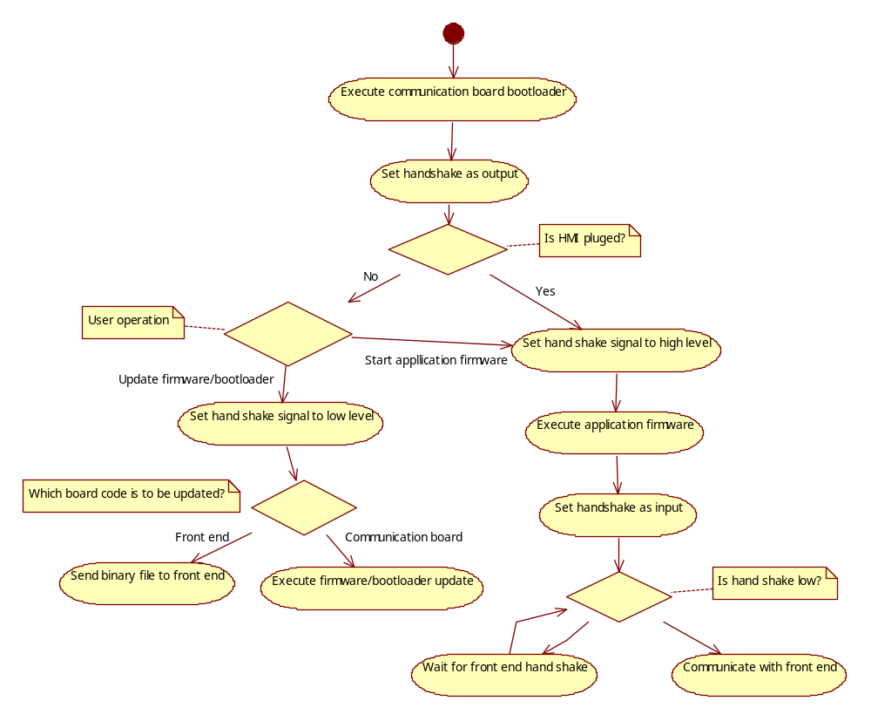

Figure 4 Communiocation board work flow chart.

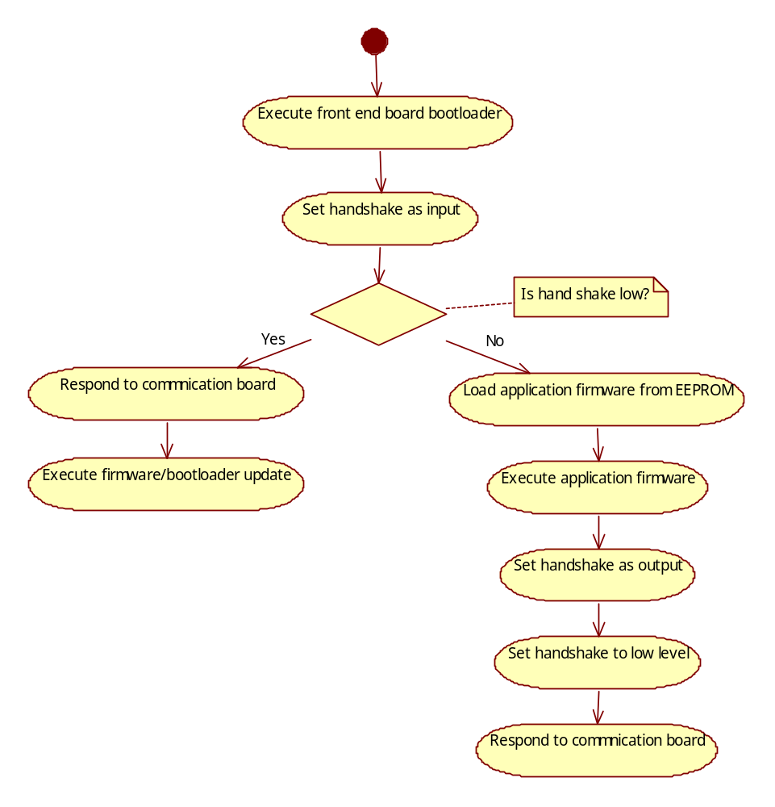
Figure 5 Front end board work flow chart

Performance Analyze
Provide measured values for execution time, code & memory size of the module/function.

Safety Design Analyze
Describe solutions founded to fulfil Safety Requirements and how the software prevents possible failures.

Appendix A Meter code

Primary Fluid | Diameter | Meter Code | Primary Fluid | Diameter | Meter Code
Vortex Liquid | DIN 15 mm | 0 | Swirl Liquid | 15 mm | 72
Vortex Liquid | DIN 25 mm | 1 | Swirl Liquid | 20 mm | 73
Vortex Liquid | DIN 40 mm | 2 | Swirl Liquid | 25 mm | 74
Vortex Liquid | DIN 50 mm | 3 | Swirl Liquid | 32 mm | 75
Vortex Liquid | DIN 80 mm | 4 | Swirl Liquid | 40 mm | 76
Vortex Liquid | DIN 100 mm | 5 | Swirl Liquid | 50 mm | 77
Vortex Liquid | DIN 150 mm | 6 | Swirl Liquid | 80 mm | 78
Vortex Liquid | DIN 200 mm | 7 | Swirl Liquid | 100 mm | 79
Vortex Liquid | DIN 250 mm | 8 | Swirl Liquid | 150 mm | 80
Vortex Liquid | DIN 300 mm | 9 | Swirl Liquid | 200 mm | 81
Vortex Liquid | ANSI 15 mm | 10 | Swirl Liquid | 300 mm | 82
Vortex Liquid | ANSI 25 mm | 11 | Swirl Liquid | 400 mm | 83
Vortex Liquid | ANSI 40 mm | 12 | Swirl Liquid |  | 84
Vortex Liquid | ANSI 50 mm | 13 | Swirl Liquid |  | 85
Vortex Liquid | ANSI 80 mm | 14 | Swirl Liquid |  | 86
Vortex Liquid | ANSI 100 mm | 15 | Swirl Liquid |  | 87
Vortex Liquid | ANSI 150 mm | 16 | Swirl Liquid |  | 88
Vortex Liquid | ANSI 200 mm | 17 | Swirl Liquid |  | 89
Vortex Liquid | ANSI 250 mm | 18 | Swirl Liquid |  | 90
Vortex Liquid | ANSI 300 mm | 19 | Swirl Liquid |  | 91
Vortex Liquid | DIN 32 mm | 20 | Swirl Liquid |  | 92
Vortex Liquid | DIN 400 mm | 21 | Swirl Liquid |  | 93
Vortex Liquid | ANSI 32 mm | 22 | Swirl Liquid |  | 94
Vortex Liquid | ANSI 400 mm | 23 | Swirl Liquid |  | 95
Vortex Gas | DIN 15 mm | 24 | Swirl Gas | 15 mm | 96
Vortex Gas | DIN 25 mm | 25 | Swirl Gas | 20 mm | 97
Vortex Gas | DIN 40 mm | 26 | Swirl Gas | 25 mm | 98
Vortex Gas | DIN 50 mm | 27 | Swirl Gas | 32 mm | 99
Vortex Gas | DIN 80 mm | 28 | Swirl Gas | 40 mm | 100
Vortex Gas | DIN 100 mm | 29 | Swirl Gas | 50 mm | 101
Vortex Gas | DIN 150 mm | 30 | Swirl Gas | 80 mm | 102
Vortex Gas | DIN 200 mm | 31 | Swirl Gas | 100 mm | 103
Vortex Gas | DIN 250 mm | 32 | Swirl Gas | 150 mm | 104
Vortex Gas | DIN 300 mm | 33 | Swirl Gas | 200 mm | 105
Vortex Gas | ANSI 15 mm | 34 | Swirl Gas | 300 mm | 106
Vortex Gas | ANSI 25 mm | 35 | Swirl Gas | 400 mm | 107
Vortex Gas | ANSI 40 mm | 36 | Swirl Gas |  | 108
Vortex Gas | ANSI 50 mm | 37 | Swirl Gas |  | 109
Vortex Gas | ANSI 80 mm | 38 | Swirl Gas |  | 110
Vortex Gas | ANSI 100 mm | 39 | Swirl Gas |  | 111
Vortex Gas | ANSI 150 mm | 40 | Swirl Gas |  | 112
Vortex Gas | ANSI 200 mm | 41 | Swirl Gas |  | 113
Vortex Gas | ANSI 250 mm | 42 | Swirl Gas |  | 114
Vortex Gas | ANSI 300 mm | 43 | Swirl Gas |  | 115
Vortex Gas | DIN 32 mm | 44 | Swirl Gas |  | 116
Vortex Gas | DIN 400 mm | 45 | Swirl Gas |  | 117
Vortex Gas | ANSI 32 mm | 46 | Swirl Gas |  | 118
Vortex Gas | ANSI 400 mm | 47 | Swirl Gas |  | 119
Vortex Steam | DIN 15 mm | 48 | Swirl Steam | 15 mm | 120
Vortex Steam | DIN 25 mm | 49 | Swirl Steam | 20 mm | 121
Vortex Steam | DIN 40 mm | 50 | Swirl Steam | 25 mm | 122
Vortex Steam | DIN 50 mm | 51 | Swirl Steam | 32 mm | 123
Vortex Steam | DIN 80 mm | 52 | Swirl Steam | 40 mm | 124
Vortex Steam | DIN 100 mm | 53 | Swirl Steam | 50 mm | 125
Vortex Steam | DIN 150 mm | 54 | Swirl Steam | 80 mm | 126
Vortex Steam | DIN 200 mm | 55 | Swirl Steam | 100 mm | 127
Vortex Steam | DIN 250 mm | 56 | Swirl Steam | 150 mm | 128
Vortex Steam | DIN 300 mm | 57 | Swirl Steam | 200 mm | 129
Vortex Steam | ANSI 15 mm | 58 | Swirl Steam | 300 mm | 130
Vortex Steam | ANSI 25 mm | 59 | Swirl Steam | 400 mm | 131
Vortex Steam | ANSI 40 mm | 60 | Swirl Steam |  | 132
Vortex Steam | ANSI 50 mm | 61 | Swirl Steam |  | 133
Vortex Steam | ANSI 80 mm | 62 | Swirl Steam |  | 134
Vortex Steam | ANSI 100 mm | 63 | Swirl Steam |  | 135
Vortex Steam | ANSI 150 mm | 64 | Swirl Steam |  | 136
Vortex Steam | ANSI 200 mm | 65 | Swirl Steam |  | 137
Vortex Steam | ANSI 250 mm | 66 | Swirl Steam |  | 138
Vortex Steam | ANSI 300 mm | 67 | Swirl Steam |  | 139
Vortex Steam | DIN 32 mm | 68 | Swirl Steam |  | 140
Vortex Steam | DIN 400 mm | 69 | Swirl Steam |  | 141
Vortex Steam | ANSI 32 mm | 70 | Swirl Steam |  | 142
Vortex Steam | ANSI 400 mm | 71 | Swirl Steam |  | 143

Reference

Ref. | Document
[1] | Andrea Andenna, VERDI Front-end Serial Communication (9ADB000700-011), 2007
Revision History
Rev. | Description of Version/Changes | Primary Author(s) | Date
0.1 | Initial revision. | Rock Li  Merrick M.X Huang  Zuochen wang | 2010-07-20
0.2 | Add Front end busy state bit.  Add write and read RTC, operation hours and maintenance cycles commands.  Add diagnosis information description.  Add Auto zero, self diagnosis and watchdog reset commands.  Add error analysis and handling section. | Merrick M.X Huang, Rock R.D Li | 2010-11-05
0.3 | Add Uart configuration in section 2.1  Add frame number and CRC16 check in each frame.  Add subcommand code in each frame.  Add NV data backup command.  Add FE firmware update command.  Add communication error handling.  Modify diagnosis information bytes. | Merrick M.X.Huang, | 2011-06-20
0.4 | Add read meter Code command.  Modify write auto zero, self diagnosis and update FE firmware command. | Merrick M.X.Huang, | 2011-07-20
0.4.1 | Modify read/write Meter Parameters command 0.  Modify update FE firmware command 128.  Add read FE firmware command 128.  Add read FE SW/HW revision command 8. | Merrick M.X.Huang, | 2011-08-04
0.4.2 | Modify read/write signal/vibration amplitude command 2/3  Remove DSP ready command 7  Add read/write DSP params command 7  Remove ADC reference voltage error bit  Add Maintenance alarm bit | Merrick M.X.Huang, | 2011-11-30
0.5 | Subcommand code is only used for command 128.  Add read command 9 and 13-23.  Add write command 8-11 and 13-23.  Add data in write command 1,2,4 | Merrick M.X.Huang, | 2012-08-30
0.6 | Add Frontend data access error bit  Add read/write SNR threshold command 12.  Add read bootloader revision command 126  Add read/write boot loader command 127.  Change NV backup command number to 16.  Add interface signal descriptions and work flow charts.  Add write FE HW revision command 3. | Merrick M.X.Huang, | 2012-09-14
0.7 | Add read/write command 60-73 for NV data backup | Merrick M.X.Huang | 2013-05-20

Review

Project: | VT5
Document Under Review: | VT5 Front End and Communication Board Communication Protocol
Revision: | 0.6
Review Date: | 2013-04-10

Review-Participant:
Place | Dept. | Name
R&D lab | PAMP | Spring Zhou
R&D lab | PAMP | Zuochen Wang

Decision of the Review:
 | Decision | next steps
q | Inspection passed without restrictions | Phase finished
Y | Inspection passed with restrictions | some changes must be done
q | Inspection not passed | Inspection must be repeated

Changes are proved: The Reviewer confirms that all changes are done:
proved Rev: | Date: | Reviewer:
0.7 | 2013-05-23 | Spring Zhou, Zuochen Wang

Check list:
 |  | yes | no
1. | Is the frame checked by 16-bit CRC? | Y
2. | Is the stuck at error checked? | Y
3. | Is a strategy for error handling designated? | N
4.
5.
6.

Remarks:

Defects
No. | Checkpoint | Description | Major  defect | done  Date
1 | 3 | Communication recovery mechanism is not described.  If the system is in communication error state, it will not clear the communication error state until there is no communication error in 1 second. | N | 2013-05-20
2 |  | NV service backup commands are required. | Y | 2013-05-20

